3 Bringing Assets into the Room
Click or Create a new room in the Asset Browser. We have a room called my first room
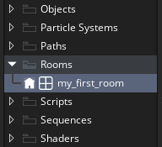
Look at the left, the dimensions of this room, might be a bit off for the size of our floor tiles, and some things might be cut off if we kept it this size.
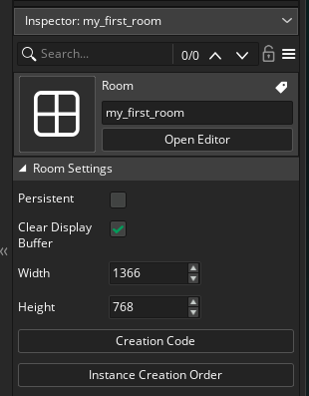
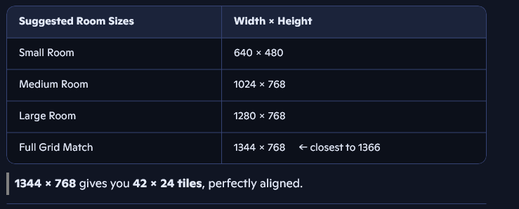
So, I just changed the width, to 1344, the height can stay the same.
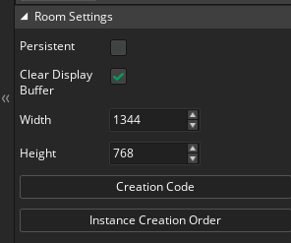

Add A Layer to Put the Tiles On
Now go to the left side of the room. We need to add a Layer.
Hit the Plus button to add a layer.
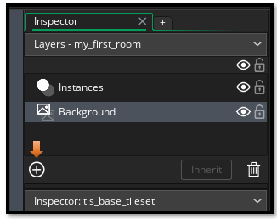
Choose the tile layer here.
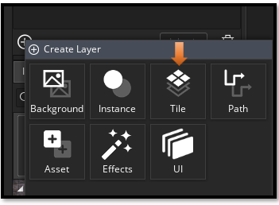
Now you have the tile layer open. You can just right click on the Tiles_1, name and choose to rename the layer if you want.
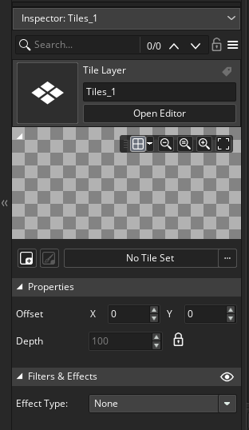
Use the Three dots at the end of the text box, that says No Tile Set and select your tile set.
